**Debugging in Python**

In software development jargon, 'debugging' term is popularly used to process of locating and rectifying errors in a program. Python's standard library contains pdb module which is a set of utilities for debugging of Python programs.

The debugging functionality is defined in a Pdb class. The module internally makes used of bdb and cmd modules.

The pdb module has a very convenient command line interface. It is imported at the time of execution of Python script by using –m switch.

python –m pdb script.py

Ex: fact.py

def fact(x):

f = 1

for i in range(1,x+1):

print (i)

f = f * i

return f

if __name__=="__main__":

print ("factorial of 3=",fact(3))

Start debugging this module from command line. In this case the execution halts at first line in the code by showing arrow (->) to its left, and producing debugger prompt (Pdb)

Ex:

C:\python36>python -m pdb fact.py

> c:\python36\fact.py(1)<module>()

-> def fact(x):

(Pdb)

To see list of all debugger commands type 'help' in front of the debugger prompt. To know more about any command use 'help <command>' syntax.

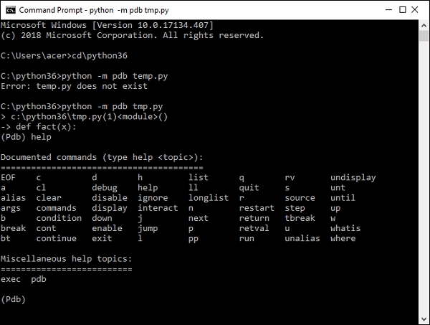

List command:

The list command lists entire code with -> symbol to the left of a line at which program has halted.

The list command lists entire code with -> symbol to the left of a line at which program has halted.

(Pdb) list

1 -> def fact(x):

2    f = 1

3    for i in range(1,x+1):

4 print (i)

5 f = f * i

6 return f

7 if __name__=="__main__":

8 print ("factorial of 3 = ", fact(3))

To move through the program line by line use step or next command.

(Pdb**) step**

> c:\python36\fact.py(7)<module>()

-> if __name__=="__main__":

(Pdb) next

> c:\python36\fact.py(8)<module>()

-> print ("factorial of 3 = ", fact(3))

(Pdb) **next**

1

2

3

factorial of 3= 6

--Return--

> c:\python36\fact.py(8)<module>()->None

-> print ("factorial of 3 = ", fact(3))

Major difference between step and next command is that step command will cause a program to stop within a function while next command executes a called function and stops after it.

C:\python36>python -m pdb fact.py

> c:\python36\fact.py(1)<module>()

-> def fact(x):

(Pdb) s

> c:\python36\fact.py(7)<module>()

-> if __name__=="__main__":

(Pdb) n

> c:\python36\fact.py(8)<module>()

-> print ("factorial of 3=",fact(3))

(Pdb) s

--Call--

> c:\python36\fact.py(1)fact()

-> def fact(x):

(Pdb) n

> c:\python36\fact.py(2)fact()

-> f = 1

(Pdb) n

> c:\python36\fact.py(3)fact()

-> for i in range(1,x+1):

(Pdb) n

> c:\python36\fact.py(4)fact()

-> print (i)

(Pdb) n

1

> c:\python36\fact.py(5)fact()

-> f = f * i

(Pdb) n

> c:\python36\fact.py(3)fact()

-> for i in range(1, x + 1):

(Pdb) n

> c:\python36\fact.py(4)fact()

-> print (i)

(Pdb) f,i

(1, 2)

(Pdb)

The step command also shows --call—indication when a program encounters a call to function and --return--- when a function is over. At any point of time, we can check the value of a certain variable by just entering its name.

**Setting up Break Points**

You can set breakpoints within a program by break command. The line number (at which breakpoint should be set)must be given. For example 'break 5' will set a breakpoint at line 5 of a current program.

(Pdb) list

2 f = 1

3 for i in range(1, x + 1):

4 print (i)

5 f = f * i

6 return f

7 -> if __name__=="__main__":

8 print ("factorial of 3=",fact(3))

[EOF]

(Pdb) break 5

Breakpoint 1 at c:\python36\fact.py:5

(Pdb) continue

1

> c:\python36\fact.py(5)fact()

-> f = f * i

(Pdb) break

Num Type Disp Enb Where

1 breakpoint keep yes at c:\python36\fact.py:5

breakpoint already hit 1 time

(Pdb) continue

2

> c:\python36\fact.py(5)fact()

-> f = f * i

(Pdb) b

Num Type Disp Enb Where

1 breakpoint keep yes at c:\python36\fact.py:5

breakpoint already hit 2 times

When 'continue' command is issued, program execution will proceed till it encounters a breakpoint. To display all breakpoints, simple issue break command without a line number.

Any breakpoint can be disabled/enabled by disable/enable command or cleared altogether by clear command.

(Pdb) disable 1

Disabled breakpoint 1 at c:\python36\fact.py:5

(Pdb) b

Num Type Disp Enb Where

1 breakpoint keep no at c:\python36\fact.py:5

breakpoint already hit 2 times

**pdb inside the script**

The Pdb debugger can be used from within Python script also. To do so, import pdb at the top of the script and use set_trace() method inside the program.

import pdb

def fact(x):

f = 1

for i in range(1,x+1):

pdb.set_trace()

print (i)

f = f * i

return f

if __name__=="__main__":

print ("factorial of 3=",fact(3))

The behavior of the debugger will be exactly the same as we find it in a command line environment.

**Debugging in Jupyter**

Ex:

list1=[1,2,3,4]

list2=[5,6,7,8]

summed_list=[]

for item in zip(list1,list2):

temp_sum=sum(item)

summed_list.append(temp_sum)

summed_list

o/p:

[6, 8, 10, 12]

To use the debugging capabilities of Jupyter, we need to enable it, by clicking on the “debugger” option :

Another example

To start debugging within the program just insert import pdb, pdb.set_trace() commands. Run your script normally and execution will stop where we have introduced a breakpoint. So basically we are hard coding a breakpoint on a line below where we call set_trace(). With python 3.7 and later versions, there is a built-in function called breakpoint() which works in the same manner.

Ex:

import pdb

def addition(a, b):

answer = a + b

return answer

pdb.set_trace()

x = input("Enter first number : ")

y = input("Enter second number : ")

sum = addition(x, y)

print(sum)